PS Lab 10

1)
Null hypothesis (H₀): All snack types are chosen with equal probability.
Alternative hypothesis (H₁): At least one snack type is not equally likely.
2)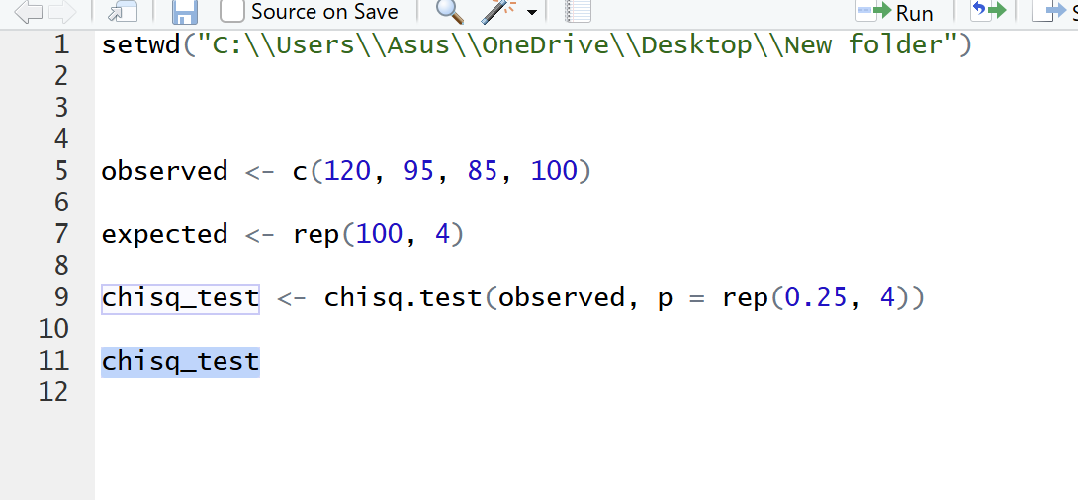

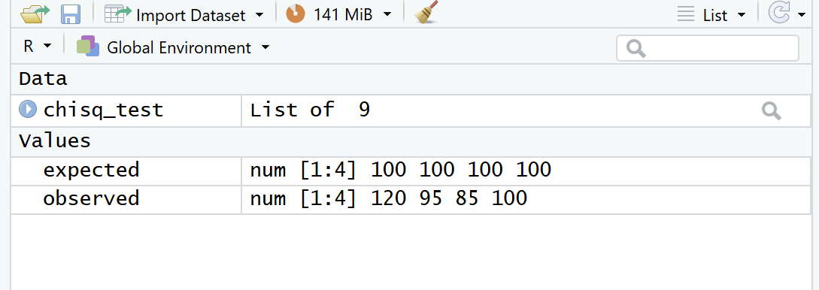

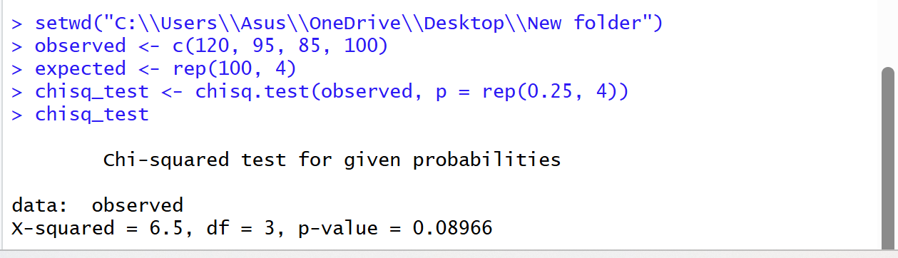

3)
There is no significant evidence to suggest that customers do not choose snacks equally. The observed variation could be due to random chance.

